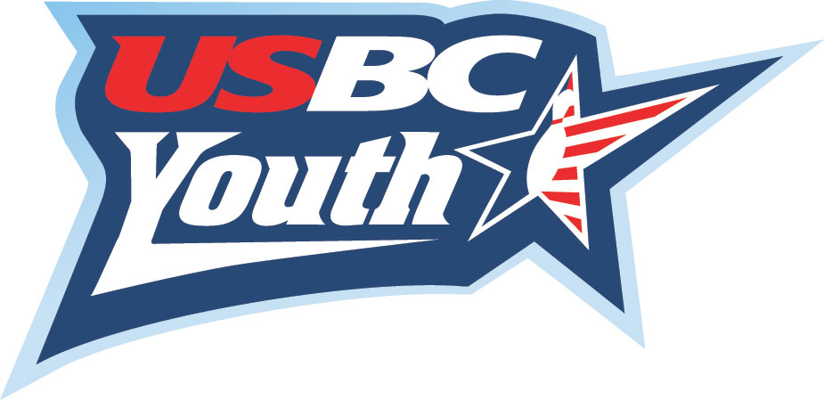

YOUTH - ADULT 9 PIN NO TAP
SINGLES SCHOLARSHIP TOURNAMENT
(Not a Doubles Tournament)

SUNDAY, MARCH 23, 2025 @ 1:30PM - Entry fee is $30.00 per person

To be held at 2 adult divisions 4 separate youth divisions

Bowlero Bradenton Men Boys 14 and Older
4208 Cortez Road Women Boys 13 and Under
Bradenton, FL 34210 Girls 14 and Older
Ph: 941-758-8838 Girls 13 and Under

This is a SCRATCH tournament for all currently sanctioned
Sarasota-Manatee USBC bowlers (Youth & Adults)
- Tournament format – 3 games. In a 9 pin no-tap tournament, 9 pins knocked down on the first ball of any frame makes that frame a STRIKE!! Take the challenge and see how high you can score. Bowling high scores is much easier this way. Sign-up for this tournament will be 45 minutes before squad starts. This is a singles tournament.
- Entry fee is divided at $13.00 for awards/prize fund, $15.00 lineage and $2.00 for the scholarship fund. Awards will be based on a 1 in 6 ratio for the total number of entries in each division. Scholarships will be the prizes awarded, and these awards will be sent to the SMART program as required by USBC guidelines for all youth bowlers. Adult prize fund will be distributed after being posted for 7 days.
- Contact Sandy Combs (941-932-7594) or Karen Shaffer (941-951-6212), with any questions. To pre-register mail entries to: Sandy Combs @ PO Box 20027 Bradenton, FL 34204
(Sponsored by the Sarasota-Manatee Youth/Scholarship Committee)
---------------------------------------------------------------------------------------------------------------

Name:________________________________________ (Circle One)
YOUTH B G
Address:______________________________________

City, Zip:______________________________________ ADULT: M F

Phone:__________________________Email:____________________________________

If Youth Bowler, Age:______________ USBC #__________________________________

Bowling Center:_______________________________

Email:_______________________________________

